Fibonacci Series Test Results

1. When path parameter {number} = 1

Output should be = [0]

Result: Pass

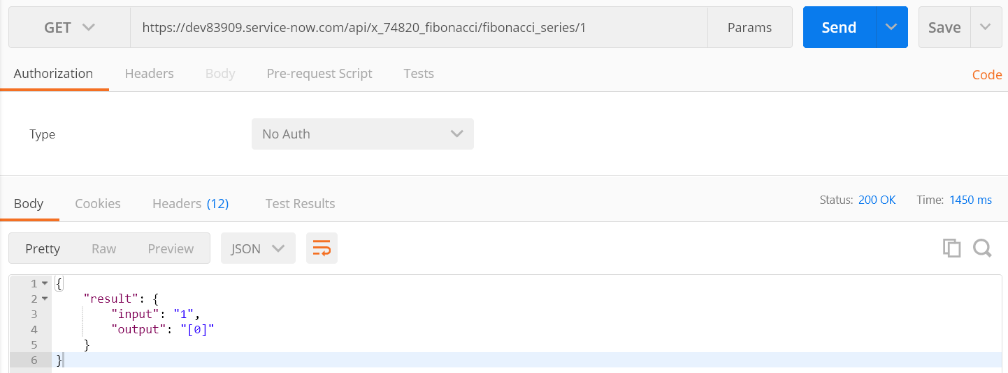

1. When path parameter {number} = 2

Output should be = [0,1]

Result: Pass

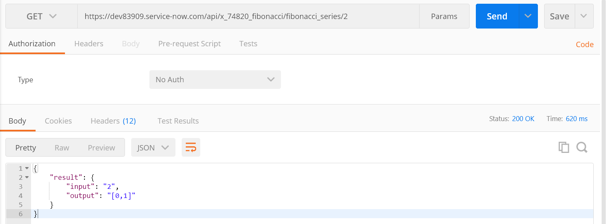

1. When path parameter {number} = 5

Output should be = [0,1,1,2,3]

Result: Pass

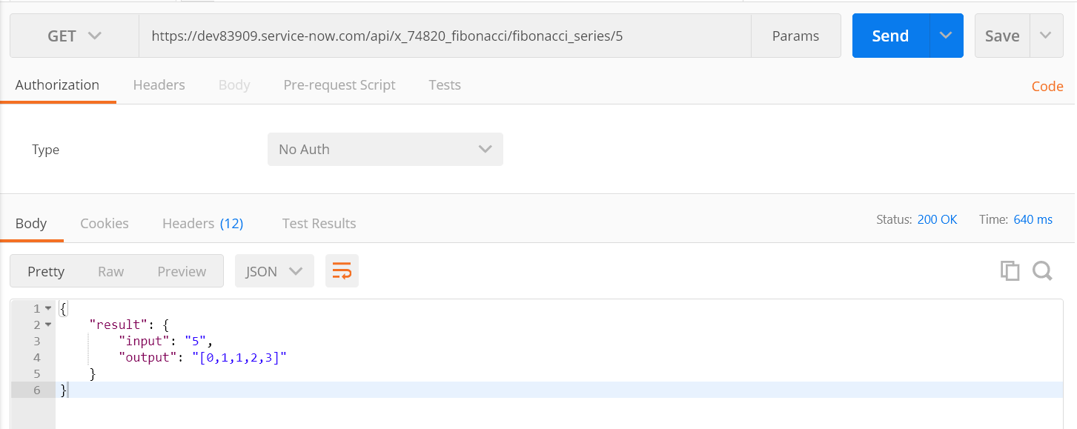

1. When path parameter {number} = 8

Output should be = [0,1,1,2,3,5,8,13]

Result: Pass

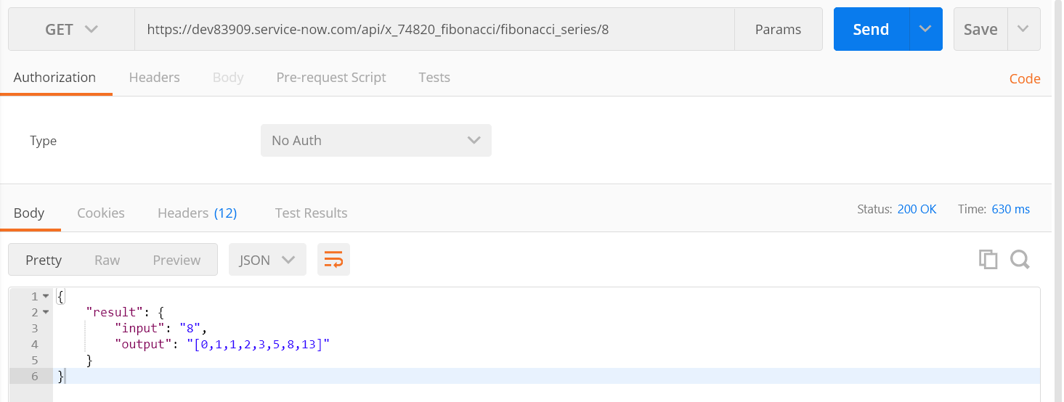

1. When path parameter {number} = 0

Output should be = Error!!

Result: Pass

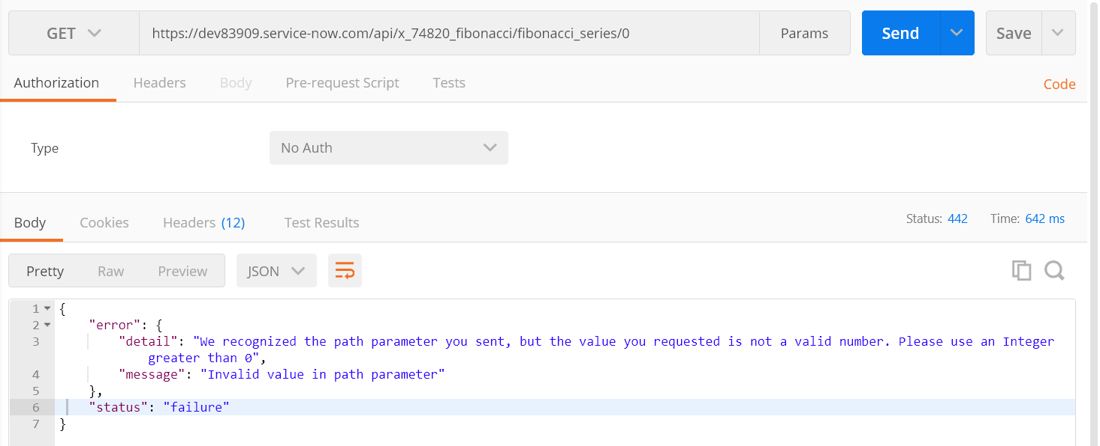

1. When path parameter {number} = -5

Output should be = Error!!

Result: Pass

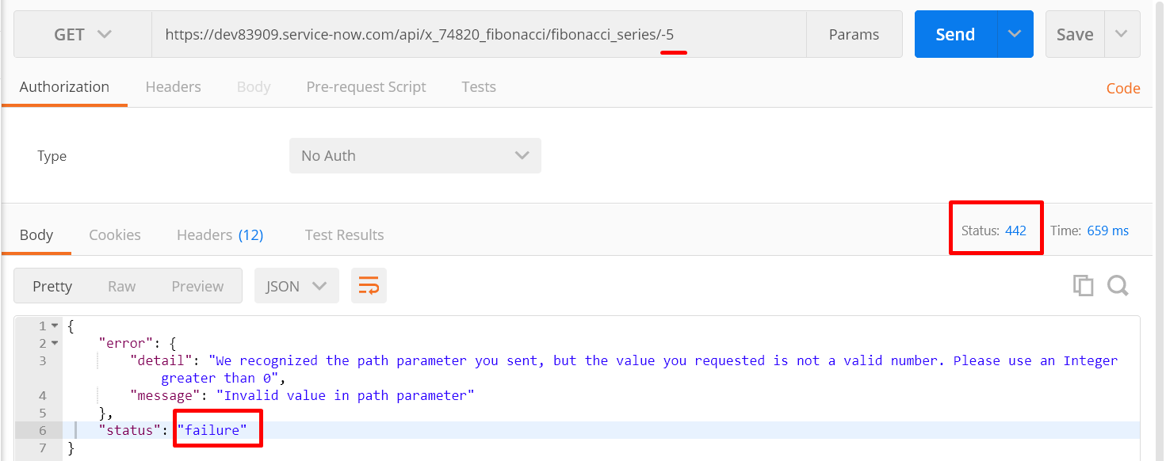

1. When path parameter {number} = Any string, null, decimal

Output should be = Error!!

Result: Pass

